It’s Sentient

Meet the classified artificial brain being developed by US intelligence programs
By Sarah Scoles Jul 31, 2019, 11:06am EDT
Illustrations by Ana Kova
At the final session of the 2019 Space Symposium in Colorado Springs, attendees straggled into a giant ballroom to listen to an Air Force official and a National Geospatial-Intelligence Agency (NGA) executive discuss, as the panel title put it, “Enterprise Disruption.” The presentation stayed as vague as the title until a direct question from the audience seemed to make the panelists squirm.
Just how good, the person wondered, had the military and intelligence communities’ algorithms gotten at interpreting data and taking action based on that analysis? They pointed out that the commercial satellite industry has software that can tally shipping containers on cargo ships and cars in parking lots soon after their pictures are snapped in space. “When will the Department of Defense have real-time, automated, global order of battle?” they asked.
“That’s a great question,” said Chirag Parikh, director of the NGA’s Office of Sciences and Methodologies. “And there’s a lot of really good classified answers.”
He paused and shifted in his seat. “What’s the next question?” he asked, smiling. But he continued talking, describing how “geospatial intelligence” no longer simply means pictures from satellites. It means anything with a timestamp and a location stamp, and the attempt to integrate all that sundry data.
Then, Parikh actually answered this question: When would that translate to near-instantaneous understanding and strategy development?
“If not now,” he said, “very soon.”
Sentient is (or at least aims to be) an omnivorous analysis tool
Parkih didn’t mention any particular programs that might help enable this kind of autonomous, real-time interpretation. But an initiative called Sentient has relevant capabilities. A product of the National Reconnaissance Office (NRO), Sentient is (or at least aims to be) an omnivorous analysis tool, capable of devouring data of all sorts, making sense of the past and present, anticipating the future, and pointing satellites toward what it determines will be the most interesting parts of that future. That, ideally, makes things simpler downstream for human analysts at other organizations, like the NGA, with which the satellite-centric NRO partners.
Until now, Sentient has been treated as a government secret, except for vague allusions in a few speeches and presentations. But recently released documents — many formerly classified secret or top secret — reveal new details about the program’s goals, progress, and reach.
Research related to Sentient has been going on since at least October 2010, when the agency posted a request for Sentient Enterprise white papers. A presentation says the program achieved its first R&D milestone in 2013, but details about what that milestone actually was remain redacted. (Deputy director of NRO’s Office of Public Affairs Karen Furgerson declined to comment on this timing in an email to The Verge.) A 2016 House Armed Services Committee hearing on national security space included a quick summary of this data-driven brain, but public meetings haven’t mentioned it since. In 2018, a presentation posted online claimed Sentient would go live that year, although Furgerson told The Verge it was currently under development.
The agency has been developing this artificial brain for years
“The NRO has not said much about Sentient publicly because it is a classified program,” says Furgerson in an email, “and NRO rarely appears before Congress in open hearings.”
The agency has been developing this artificial brain for years, but details available to the public remain scarce. “It ingests high volumes of data and processes it,” says Furgerson. “Sentient catalogs normal patterns, detects anomalies, and helps forecast and model adversaries’ potential courses of action.” The NRO did not provide examples of patterns or anomalies, but one could imagine that things like “not moving a missile” versus “moving a missile” might be on the list. Those forecasts in hand, Sentient could turn satellites’ sensors to the right place at the right time to catch ill will (or whatever else it wants to see) in action. “Sentient is a thinking system,” says Furgerson.
It’s not all dystopian: the documents released by the NRO also imply that Sentient can make satellites more efficient and productive. It could also free up humans to focus on deep analysis rather than tedious needle-finding. But it could also contain unquestioned biases, come to dubious conclusions, and raise civil liberties concerns. Because of its secretive nature, we don’t know much about those potential problems.
“The NRO’s and the Intelligence Community’s standard practice is to NOT disclose sensitive sources and methods, as such disclosure introduces high risk of adversary nations’ countering them,” says Furgerson. “Such loss harms our nation and its allies; it decreases U.S. information advantage and national security. For those reasons, details about Sentient remain classified and what we can say about it is limited.”

Satellite programs have generally been some of the most hush-hush intelligence initiatives. The first program to take pictures from space, Corona, began in 1958, and the satellite successfully shot its first bucket of film back through the atmosphere in August 1960. A few days later, Edwin Land, CEO of Polaroid, unspooled the film across the floor of the Oval Office while Dwight Eisenhower watched. Before him lay likenesses of airfields and military installations in the Soviet Union.
“Here are your pictures, Mr. President,” said Land.
That big reveal, according to an official history from the NRO, directly led to the creation of a new agency responsible for the “design, acquisition, and operation of reconnaissance satellites.”
The NRO was formally established the next year.
In the 1970s, the office started launching “Keyhole”-class satellites that had specs similar to the Hubble Space Telescope’s, but they were aimed at Earth instead of other galaxies. We also know that the NRO’s orbital collection includes data collected during the test or operation of aircraft, missiles, or other systems; intercepted voice, text, or image communications; and radar, among other sources. Of the more than 150 (known) US military satellites, the NRO operates around 50.
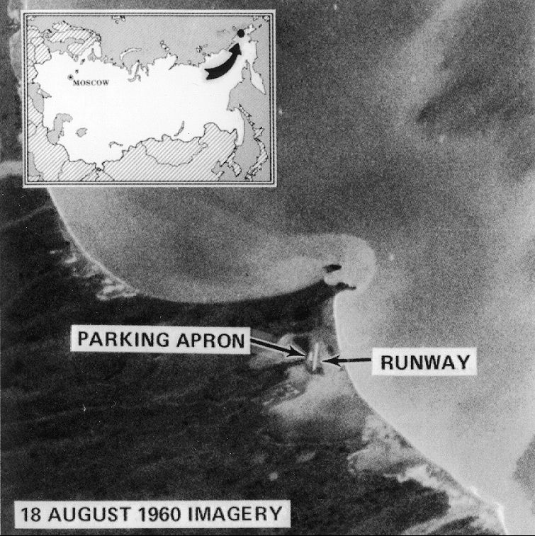
Satellite image of the USSR taken by CORONA. Image: NRO
Now, nearly six decades after the NRO was founded, the sky is crowded with other downward-looking satellites, some owned by private intelligence companies. One of these, BlackSky, uses those satellites to feed into a system that’s essentially Sentient’s unclassified doppelgänger.
When two oil tankers were attacked in the Strait of Hormuz on June 13th, BlackSky’s program sent its satellites into action and took pictures of the incident while smoke from the explosions was still spiraling skyward. The ships’ drifting beacons and local news reports hinted that something was up, prompting BlackSky analysts to turn their attention to the busy shipping lane near Iran.
Insiders call that process “tipping and cueing”: using a data tip-off from one source to cue a satellite to look at a particular spot, or using information from a satellite to spin up another instrument’s collection. In the ideal version of that process, an automated system sucks in all sorts of data, synthesizes it into something sensible, cues the satellite symphony, reincorporates the satellites’ data back into the analysis loop, comes to a smarter conclusion, points the satellites or other sensors again, and repeats the entire process. Do that well enough, and a company (or intelligence agency) could build a tower of knowledge about the past, comprehend present events faster than their competitors, and — maybe someday — predict the future.
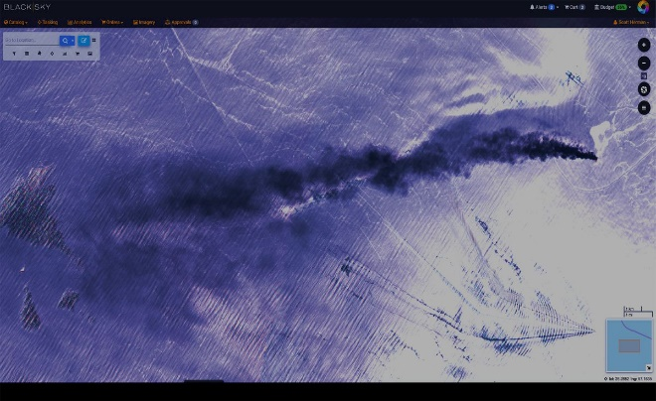
Satellite image of oil tanker struck in the Gulf of Oman, June 2019. Image: BlackSky
As the commercial industry has built up its network of Earth-observing orbiters, the intelligence community has taken notice. In 2016, the NGA, which analyzes data the NRO collects, and the NRO jointly announced the Commercial GEOINT program to better buy this data. In 2017, the NRO took over purchasing responsibility, and has since signed at least three new contracts. One was with a company called Maxar, which owns some of the most powerful high-resolution satellites in the private sector and, for a long time, was pretty much the only company selling satellite images to the NRO. This time, though, the agency also signed another deal with Planet, which operates a constellation of small satellites that image all of Earth’s land every day. The third contractor is BlackSky.
Here’s where Sentient reenters the picture: All the images from the NRO, the military, and these commercial satellite firms, combined with other geospatial intelligence — anything that has a time tag and a location tag — create a vast amount of information that’s far more than a literal army of people could comb through. To keep up with the fire hose of information, the NRO turns in part to AI. “Sentient aims to help analysts ‘connect the dots’ in a large volume of data,” Furgerson says.

How might Sentient connect the dots, though? We don’t know, exactly. Released documents do not explicitly say which sorts of data sources Sentient may siphon in, but it’s clear that the program is interested in all kinds of information. “It could include electronic intercepts of international communications; it could include prior imagery; it could include human sources,” says Steven Aftergood, a researcher at the Federation of American Scientists and director of the Project on Government Secrecy. “People saying, ‘Hey, there’s something going on over that hill.”
Retired CIA analyst Allen Thomson goes further. “As I understand it, the intended — and aspirational — answer is ‘everything,’” he says. In addition to images, that could include financial data, weather information, shipping stats, information from Google searches, records of pharmaceutical purchases, and more, he says.
Consider what’s happening in the private sector: BlackSky takes data from 25 satellites, more than 40,000 news sources, 100 million mobile devices, 70,000 ships and planes, eight social networks, 5,000 environmental sensors, and thousands of Internet-of-Things devices. In the future, it plans to have up to 60 of its own Earth-observing satellites. All of that information goes into different processing pipelines based on its type. From a news story, BlackSky may extract people, places, organizations, and keywords. From an image, it may map out which buildings appear damaged after an earthquake. All of that processed, but still disparate, data goes into what BlackSky CTO Scott Herman calls a “giant analytic fusion engine,” which tries to turn it into more than the sum of its parts, tells satellites what to do about it, and alerts human analysts when events meet certain predetermined criteria.
“Just how far Sentient has gotten or will get isn’t clear.”
In the real world, BlackSky might use that to keep track of the positions of Russian jets. The company has images of places where the Russian military parks its planes, and it knows the rough shape of different kinds of flyers.
The company also has shape-recognition algorithms, able to pick out pixels that, together, map out a given pattern. It can tune that algorithm to pick out the outlines of Russian jets, like the MiG Fulcrum and Foxhound planes. Once you put the satellite pictures into that algorithm, you could learn how many of those aircraft are sitting on runways. Understanding the significance of that count — what “45 Fulcrums at Aleysk but none at Krymsk” actually means — takes even more data. The system would need to know the history of jet demographics, which it could have determined from prior observations. It could perhaps gather data on how often they fly and where, or even look at news to find out whether there’s any agitation or action around Aleysk: now the system knows exactly where they should point their real-time satellites to gather the information that their client needs.
BlackSky is really just getting started, having only recently launched its own satellites. The ultimate success and utility of its system still have to be proven. And based on the available information, it’s unclear how far along Sentient’s comparable system is. Thomson suspects its more grandiose goals are still simply that: goals. “Just how far Sentient has gotten or will get isn’t clear,” he says.
“If it were to be implemented successfully on a large scale, it would certainly be a significant advance,” says Thomson, “but I didn’t see any indication that that had actually happened.”
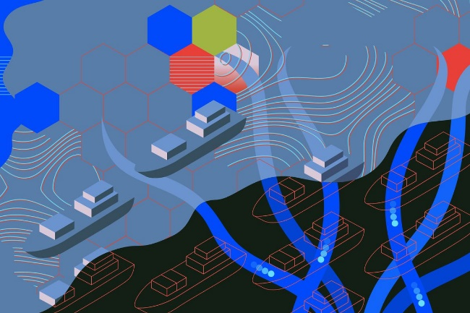
Even if Sentient is still stuck in its early stages, its existence sends up a lot of red flags for privacy experts. Do the algorithms actually work? In what ways are they biased? How many false positives do they generate? “How often is Sentient going to send our billion-dollar satellites on a wild goose chase?” asks Aftergood. “We have to consider the impact of Sentient leading us astray.”
The NRO notes that Sentient doesn’t keep people totally out of the process, providing some kind of check on its state of being. “Having humans in the loop overseeing the intelligence data and information is a key way of monitoring the algorithm’s performance,” says Furgerson. “Sentient is human-aided machine-to-machine learning.”
when you’re asking silicon to make sense, you have to train it on the right kind of data
Of his company’s work, Herman notes that when you’re asking silicon to make sense, you have to train it on the right kind of data. If you want algorithms to learn what radio towers look like, but you only ever show them radio towers in full sunlight, they will come to think “black shadow next to tower” is, in fact, integral to the tower’s towerness. If they then look at a snap of such a structure on a cloudy day, they won’t recognize it at all.
That’s a banal example, but you can imagine more sinister ones — like software that has learned the word “bomb” is associated with terrorist plans, but never learns that “that’s the bomb” is a chill phrase. In AI’s other realms, it hasn’t actually proven omniscient or objective, usually in ways that hurt not-white guys. At Amazon, for instance, facial recognition software consistently failed at identifying the genders of women and darker-skinned people. Analytics company Palantir created a predictive law-enforcement program for the police force of New Orleans, but fed it data that according to some reports targeted minorities unfairly.
What biases might lurk inside Sentient? What has its training data looked like? Who’s validating its conclusions, and how? At the moment, the answers are opaque, but secrecy watchdogs like Aftergood are asking anyway. “Those are the questions you don’t want the sponsors or funders of Sentient to be asking and answering by themselves,” says Aftergood.

Questions about who and what Sentient monitors are equally persistent and also nearly unanswerable, but there are a few clues about where the program may or may not be peeking. Spy satellites, like the ones used by the NRO, are primarily meant to focus on the world beyond the United States’ borders. And unlike its fellow intelligence agencies — including the NSA and CIA — the NRO hasn’t really been caught up in major domestic-spying scandals. Its biggest recent public upset was probably about the mission patch for the launch of its NROL-39 satellite: it depicts a giant yellow octopus mouth-suctioned to Earth — to North America, actually. Tentacles encircle the planet. The words “NOTHING IS BEYOND OUR REACH” smile in an arc below the cephalopod.
Despite the patch’s sentiment, there are some places where the NRO and Sentient are generally not supposed to reach. In heaven as on Earth, laws protect American citizens from unreasonable search and seizure by their government. “Under the existing statutory regime, Sentient-driven reconnaissance should not be taking place within the US,” says Aftergood. “If it were, that would of course immediately raise privacy and civil liberties concerns, and a whole set of related questions about how that collected information was being used and stored and so on. But right now it shouldn’t be collected in the first place.”
In response to questions about potential domestic surveillance, the spokesperson noted that the NRO obeys the intelligence community’s prime directive — Executive Order 12333, as well as other applicable laws. This particular executive order outlines when “collection, retention, and dissemination” of intelligence about people in the US is allowed — provided the collectors follow proper procedure. Notably, though, one of the order’s exceptions to the “leave the US alone” policy is when intelligence is “acquired by overhead reconnaissance not directed at specific United States persons.”
They’re not supposed to be snooping for snooping’s sake
But Executive Order 12333 outlines principles governing intelligence agencies and doesn’t apply in the same way to the private Earth-observation companies that have proliferated in recent years, BlackSky being one of them. Corporations can point their telescopes pretty much anywhere they like. Although the government does reserve the right to exercise “shutter control,” prohibiting photography of a certain area, it has never done so (sometimes the government does buy exclusive access to an area, a practice known as “checkbook shutter control”). Limits do exist on the resolutions at which private companies can sell images to the public and to other countries.
For the most part, companies like Maxar, Planet, and BlackSky take pictures that anyone with a fat enough checkbook can purchase — including you, and including organizations like the NRO. That raises some interesting legal questions that researchers like Aftergood are still trying to figure out: if NRO was interested in surveilling the US, and can’t deliberately use its satellites to focus in on your house, could it simply buy pictures of your house from a private company instead?
The NRO did not provide a specific answer on commercial data’s role in Sentient. But limits, says Aftergood, should still exist on paid-for data. “What they do with that should in some way be mission-oriented,” says Aftergood. “They’re not supposed to be snooping for snooping’s sake.”
For now, Sentient’s snooping remains secret. The thinking system speaks only to those with a security clearance, although it may listen to, as Thomson put it, just about everything.

