Straussian Philosophy of the Post 9-11 Politics
(respectfully condensed from Straussism: The Philosophy Directing The Age Of Tyranny By Jan Allen) http://www.informationclearinghouse.info/article13145.htm)
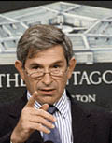
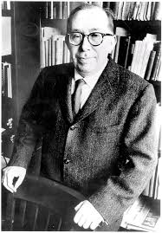
Leo Strauss (1899-1973) was a Jewish student of philosophy forced to flee Germany and ended up teaching philosophy at the University of Chicago. He was an atheist who believed there were only rewards and punishments in this life. Strauss longed to return to a previous era of imperial domination and authoritarian rule. The students of Leo Strauss joined the Republican party, formed neo-conservatism and became known as Neocons. Strauss believed in tyranny or rule by a society of elitists, demonstrated by the rhetoric and behavior of the George Bush neocon administration which announced the New World Order in 1992. Neo-conservatism is the ultimate stealth weapon of mass destruction whose purpose is to destroy liberty and affluence. American neoconservatives have decided to conquer the world in the name of liberty and democracy, but they are turning the world into the Nazi Germany Leo Strauss fled from.
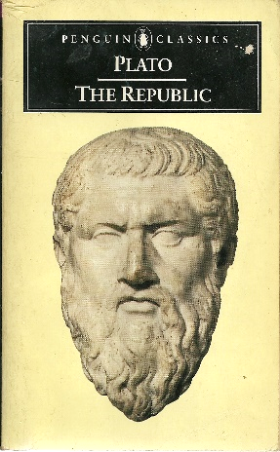
Neo-conservatism is inspired by Strauss’s hatred for freedom, liberty and the individual. Its goal is to aggressively turn back the clock on the liberal revolution and its achievements. 9/11 provided the perfect pretext of Straussian principles to be implemented on a global scale. Paul Wolfowitz (Deputy Secretary of War on 9-11), who attended Strauss's lectures on Plato, became the architect of the Iraq War, using hyped intelligence about WMD's as the "noble lie".
Strauss’ ideology has its roots in ideas contained in Plato’s Republic. His interpretation of Plato’s Philosopher King put forward a belief in a totalitarian system run by an elite who saw themselves as “absolute rulers” who rule through deception and lies designed to keep the general population in blissful ignorance and docile servitude. Society should be divided into two classes: the elite who should lead (having the interests of the people at heart), and the masses who should follow. In contrast, the writer James Horrox comments:
“Americans cannot credit their leaders with having the interests of society at heart. Do the neocons invoke the bogey-man of international terrorism as a means of pulling the wool over the eyes of the American people while they pocket the financial profits of military conflict? There is nothing ‘noble’ about the lies propagated by the neocons: the vast web of private financial interests reaping enormous financial rewards from the global conflict spawned by neocon-dominated foreign policy points more to a cabal of crooks and con-men acting out of pure and unashamed self-interest than Plato’s ideal of the Philosopher King.”
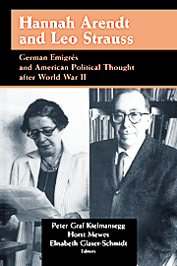
As a young man in Germany, Leo Strauss met the Jewish scholar, Hannah Arendt, who did not conceal her contempt for his ideas. Her brilliant analysis, The Origins of Totalitarianism, can help us understand the erosion of democracy since 9/11. Her concept of the "banality of evil" is useful in understanding how ordinary individuals can plan and carry out acts of inhumanity. Her book The Human Condition is her most important work. Strauss and Arendt represent the two poles of the ideological struggle.
Murder Is A Virtue
Athens, the ideal democracy, weakened by plague, suffered a terrible defeat at the hands of oligarchic Sparta and its allies. Strauss, following Plato, did not grieve for the loss of Athens because the real city had been no match for the ideal city. In truth, the larger Spartan armies overwhelmed Athens with technology (ships) and strength in number. The Straussians in the Department of Defense and in the think tanks took this to mean that they could kill on principle. They did and they do. The first Bush sent his Spartan general to Iraq, and the second sent the same Spartan to the Security Council. The Straussians could not call their work politics, so they called it virtue.

The Few Must Rule The Many
Strauss taught: “The strong must rule the weak” To Strauss, the superiority of the “philosopher kings” is an intellectual superiority and not a moral one. The elite few are to have unlimited state power to pursue their own virtuous vision of the so-called “public good.” Moral virtue had no application to the really intelligent man, the wise philosopher. Moral virtue only serves the purpose of controlling the unintelligent majority. They claim they understand the "hidden meaning" of history and historical documents, which is often directly at odds with the plain historical facts.

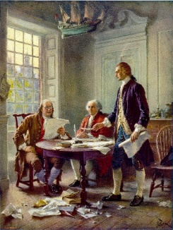
John Locke and the American founding fathers held that man possesses natural rights to life, liberty, and property and that the state is always and everywhere the greatest threat to these God-given rights. To Thomas Jefferson and other founding fathers, this meant that government should be “bound by the chains” of the Constitution which separates the state and religion. Straussians thought that separation of church and state was a big mistake. Madison wrote, “If men were angels, there would be no need for government,” in defense of the Constitution, “but men are not angels, which is why government power must always be limited.”

Destroy Democracy
“The Rule Of The Wise” is unquestionable, absolute, authoritarian, undemocratic and covert. Classic democratic values such as justice or constitutional principles do not apply. Those in power make the rules in their own interests and call it justice. Leo Strauss said: “It would be equally absurd to hamper the free flow of wisdom by consideration of the unwise wishes of the unwise; hence the wise rulers ought not to be responsible to the unwise subjects. The more gullible and unperceptive they are, the easier it is for the wise to control and manipulate them.” Under this autocratic system, dissent is not only dangerous, it is seditious.
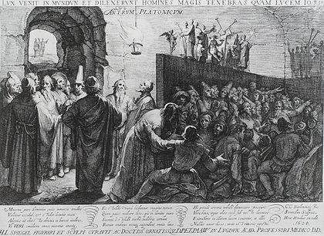
Only One Natural Right: The Right To Rule Over The Vulgar Many
Strauss says human beings are born neither free nor equal. The natural human condition, is not one of freedom, but of subordination. There is only one natural right – the right of the superior to rule over the inferior, the master over the slave, the husband over the wife, and the wise few over the vulgar many. The Straussian thinks the people of the United States are the “vulgar many,” chumps, dupes, and ciphers to be manipulated, poked, and prodded in the direction of the “Long War,” a new Hundred Years’ War, as spelled out by Rumsfeld’s Quadrennial Defense Review. “A policy of perpetual war against a threatening enemy is the best way to ward off political decay. And if the enemy cannot be found, then it must be invented.”
The Three Classes: The Wise-Few, The Vulgar-Many And The Gentlemen
The wise are the lovers of the harsh, unadulterated truth. They are capable of looking into the abyss without fear and trembling. They recognize neither God nor moral imperatives. They are devoted above all else to their own pursuit of the “higher” pleasures. The vulgar many, are lovers of wealth and pleasure. They are selfish, slothful, and indolent. They can be inspired to rise above their brutish existence only by fear of impending death or catastrophe. If the Few were to give the Many, such things as freedom, happiness, and prosperity, in Strauss's estimation, this would turn them into animals. The goal of the wise is to ennoble the vulgar. But what could possibly ennoble the vulgar? Only weeping, worshipping and sacrificing ennobles the many. The gentlemen who wield the reins of power are lovers of honor and glory. They are true believers in God, honor, and moral imperatives. They are ready and willing to embark on acts of great courage and self-sacrifice at a moment’s notice. They rally patriotic fervor against the nation’s external enemies as well as its internal decadence, sloth, pleasure, and consumption, in the belief that their nation and its values are the best in the world, and that all other cultures and their values are inferior in comparison.
The State Is Omnipotent: It Manifests Militaristic Nationalism
Strauss believed that human aggression could only be restrained by a powerful, nationalistic state. He believed that such an omnipotent state can only be maintained if there is an external threat, "even if one has to be manufactured." This is why Straussians believe in perpetual war and is another reason why they have formed a cult around "the church of Lincoln," whom they hold up as "the greatest statesman in history." Lincoln manufactured many "threats," including the truly bizarre notion that representative government would perish from the earth if the Southern states were permitted to secede peacefully. In reality, peaceful secession would have been a victory for self-government, keeping in mind that neither Lincoln nor Congress ever said that they were launching an invasion for any reason having to do with liberating the slaves.
Perpetual War
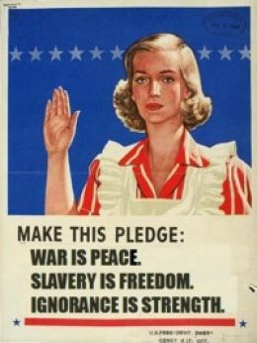
Strauss taught that war would enable us to see evil, restore virtue, heroism, valor, and a sense of sacrifice, allow us to die for our comrades, country and faith, avoid the "hazards of civilization," make us more thoughtful, force us to “consider our loyalties," make men "decisive", and "place greatness within the reach of ordinary men.” “Because mankind is intrinsically wicked, he has to be governed which can only be established when men are united and they can only be united against other people." The only way a political order can be stable is if it is united by an external threat. Wealth, freedom, and prosperity make people soft, pampered, and depraved. War is an antidote to moral decadence and depravity. Thus war is held to be redemptive and perpetual war is necessary. Straussians believe in an aggressive, belligerent foreign policy for a world order dominated by U.S. military power. Neoconservatives see foreign policy as a means to fulfill a "national destiny", as Irving Kristol defined it in 1983, that goes far beyond the narrow confines of a “myopic national security.”
Culture of Lies, Deceit and Confusion
Strauss advocates the maintenance of a culture of lying through a compliant media and professional spokes-liars, and carry on a perpetual campaign to confuse the public and keep it ignorant of the elites political designs. The result of this is that Elite operate from a shroud of secrecy; thus their reasonings and logic is nontransparent, while they make public declarations that everything they do is transparent. In a world devoted to the modern ideas of equal, rights and freedoms, that they are in a situation of great danger, so they justify lying in order to avoid persecution. Strauss says that a culture of lying is the “peculiar justice of the wise.”
Deception is carried on continually. Lies are to be both aggressive and perpetual. If the vulgar many were exposed to anything other than the maintained reality, they would quickly fall into nihilism or anarchy. Strauss advocated an Orwellian double speak method of communication. Lies are virtuous and noble instruments of wise policy to keep the many from the dangers of liberalism and democracy. Plato himself advised his nobles, men with golden souls, to tell noble lies, that is, political fables, much like the specter of Saddam Hussein with a nuclear bomb: to rally the people, to keep the other levels of human society (silver, iron, brass) in their proper places, loyal to the state and willing to do its bidding. Wrap speeches with the American flag giving the appearance of appearance of legitimacy in dissimulation and deceit.
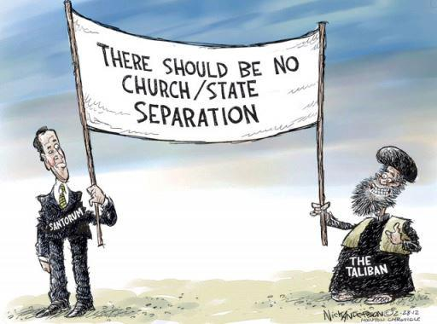
One State Religion
Strauss argued against coexisting religions which would break the society apart because it would lead to individualism, liberalism, and relativism, traits that promote dissent that could dangerously weaken society's ability to cope with external threats or not be available for aggressive nationalism. Strauss proposed that a state religion maintained absolutes, countered free thought, and enforced a cohesive unity. Religion was for the many alone but the elite need not be bound by it.

On the other hand, consider the writing of Shadia Drury:
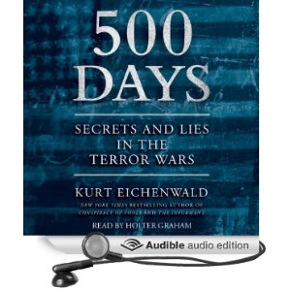
Using religion as a political tool has two equally unsavory consequences. First, when religious beliefs become the guide for public policy, the social virtues of tolerance, freedom, and plurality are undermined, if they are not extinguished altogether. Second, the use of religion as a political tool encourages the cultivation of an elite of liars and frauds who exempt themselves from the rules they apply to the rest of humanity. And this is a recipe for tyranny, not freedom or democracy.
Secrecy Is Essential
The wise must conceal their views for two reasons – to spare the people’s feelings and to protect the elite from possible reprisals. People will not be happy to learn that there is only one natural right – the right of the superior to rule over the inferior, and both lies and secrecy are thus necessary to protect the superior few from the persecution of the vulgar many.
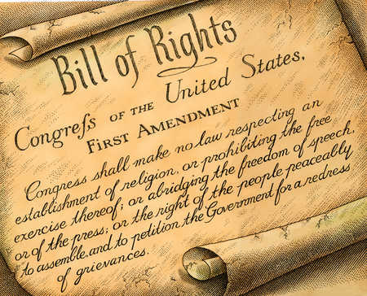
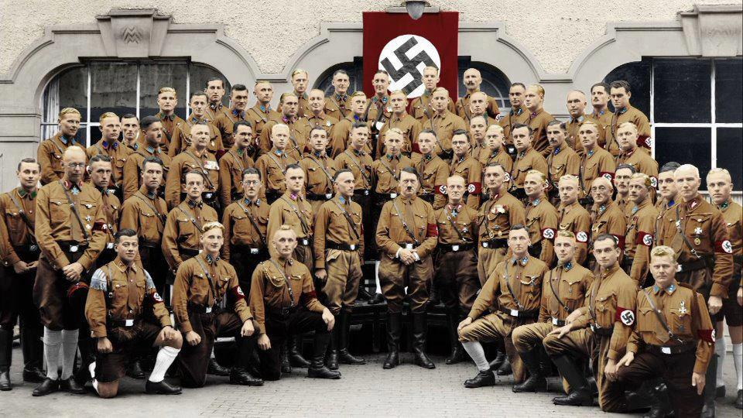
Nature Abhors A Contract
Natural law, interpreted by Bush's "wise counsels," gave the President permission to launch a preemptive war through an appeal to the higher power. Natural-law theory assumes that men seek the good and although their action wasn’t legal, it was “right.” In contrast, the Founding Fathers espoused natural-law theory, saying that natural law was both divine and self-evident. But the Founders were concerned with inalienable natural rights and after much debate in their convention, they wrote a contract, the Constitution.
Long before the events of September 11, 2001, the Bush Administration had made a decision to oust Saddam Hussein for philosophical reasons. The 9-11 attack was based on principles the planners derived from natural law, the innate ability to know right from wrong, took precedence over mere convention. The Bush regime violated the contract that was agreed to when the United States joined the United Nations; it flouted the U.S. Constitution, which is also a contract, by attacking without the required declaration of war by the Congress; and it disregarded the Geneva Conventions in its treatment of prisoners at Guantanamo Bay, Cuba, and in other secret detention camps around the world. The administration's wise men held up Strauss's version of natural law as the model, dismissing contracts as mere laws of men.
Intimidate All Opponents
The other faculty and students at Chicago viewed the Straussians as brown shirts which refers to Hilter’s society of stalkers who wore brown shirts, engaged in a campaign of deliberate intimidation. This is what we are seeing today through a national/international system of electronic harassment, implantation of electronic devices and attacks with directed energy, fusion center computerized organized stalking and making people sick with biological weapons and entomological terrorism, which is meant to censor, intimidate, cause suicides or kill outright, those who disagree with the Neocon Nazis of the New World Order.
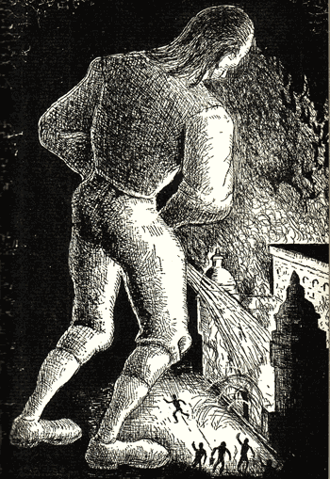
Extinguish The Fires With Martial Law
Leo Strauss often talked about Jonathan Swift's story of Gulliver and the Lilliputians. ''When Lilliput was on fire, Gulliver urinated over the city, including the palace. In so doing, he saved all of Lilliput from catastrophe, but the Lilliputians were outraged and appalled by such a show of disrespect.''
The fires are the modern licentious doctrines and philosophies of individualism, liberty, legalism and constitutionalism. The fires have resulted in great social decay, divorce, delinquency, crime, and abounding creature comforts and have created seditious constructs of contracts, statutes and constitutions. Supposedly, America is on fire and in order for it to be saved, the fires must be extinguished through the institution of martial law. Don’t believe it!
References for this material came from these sources and others:
Leo Strauss' Philosophy of Deception
http://www.alternet.org/story/15935
The Cult of Leo Strauss: Leo Strauss
http://www.catalystmagazine.net/issues/story.cfm?story=475
Ignoble liars: Leo Strauss, George Bush, and the philosophy of mass deception
http://www.lacosapizza.com/shorris.html
Straussians: Mass Murder at the Mall as Gospel
http://kurtnimmo.com/?p=338
Noble lies and perpetual war: Leo Strauss, the neo-cons, and Iraq
http://www.informationclearinghouse.info/article5010.htm
The Strong Must Rule The Weak
http://www.fpif.org/commentary/2003/0305strauss_body.html
Neocons Dance A Straussian Waltz
http://www.atimes.com/atimes/Middle_East/EE09Ak01.html
Leo Strauss and the neoconservatives
http://www.informationclearinghouse.info/article6750.htm
Copyright Jan Allen - Visit her website http://my.opera.com/prosperingbear/blog/

The Straussian disciples formed the neoconservative manifesto of the Project for the New American Century (PNAC) which was a neoconservative think tank based in Washington, D.C. that focused on US foreign policy. It was established as a non-profit organization in 1997 whose goal was "to promote American global leadership". The organization stated that "American leadership is good both for America and for the world," and sought to build support for a policy of military strength. The PNAC played a key role in building support for the Iraq War. See Wiki PNAC. https://en.wikipedia.org/wiki/Project_for_the_New_American_Century
Leo Strauss and the Cult of the Noble Lie (excerpts) by James Horrox http://www.dominican.edu/academics/osher/plone-cleanup-olli/archives/prior-sessions/spring/case-against-democracy-3
The parallel rise of Athens to a major power in Greece led inevitably to friction with Sparta, and to two large-scale conflicts, (the First and Second Peloponnesian Wars), which devastated Greece. Sparta suffered several defeats during these wars, including, for the first time, the surrender of an entire Spartan unit at Sphacteria in 425 BC, but ultimately emerged victorious, primarily through the aid it received from the Persians. Under its admiral Lysander, the Persian-funded Peloponnesian fleet captured the cities of the Athenian alliance, and a decisive naval victory at Aegospotami forced Athens to capitulate. The Athenian defeat left Sparta in a dominant position in Greece, and Sparta finally gained primacy due to its military forces. See Wiki Spartan Army.
http://www.ipsnews.net/2003/05/politics-us-strong-must-rule-the-weak-said-neo-cons-muse/
http://history.defense.gov/Portals/70/Documents/quadrennial/QDR2001.pdf
The Allegory of the Cave is presented by the Greek philosopher Plato in his work The Republic (514a–520a) to compare "the effect of education and the lack of it on our nature". Plato has Socrates describe a gathering of people who have lived chained to the wall of a cave all of their lives, facing a blank wall. The people watch shadows projected on the wall from things passing in front of a fire behind them, and they begin to give names to these shadows. The shadows are as close as the prisoners get to viewing reality. He then explains how the philosopher is like a prisoner who is freed from the cave and comes to understand that the shadows on the wall do not make up reality at all, for he can perceive the true form of reality rather than the mere shadows seen by the prisoners.
http://www.alternet.org/story/15935/leo_strauss'_philosophy_of_deception What would you do if you wanted to topple Saddam Hussein, but your intelligence agencies couldn't find the evidence to justify a war? A follower of Leo Strauss may just hire the "right" kind of men to get the job done – people with the intellect, acuity, and, if necessary, the political commitment, polemical skills, and, above all, the imagination to find the evidence that career intelligence officers could not detect. The "right" man for Deputy Defense Secretary Paul Wolfowitz, suggests Seymour Hersh in his recent New Yorker article entitled 'Selective Intelligence,' was Abram Shulsky, director of the Office of Special Plans (OSP) – an agency created specifically to find the evidence of WMDs and/or links with Al Qaeda, piece it together, and clinch the case for the invasion of Iraq.
On the morning of September 11, 2001, the Secretary General of the United Nations, Kofi Annan, was speaking in New York at the opening of the UN General Assembly. He reminded the gathering that this was the 20th anniversary of the INTERNATIONAL DAY OF PEACE, "a day of world-wide peace and goodwill". He was just about to lead a moment of silence in the name of peace when the first jet struck the north tower of the World Trade Center. That day, 9-11, began the WORLD-WIDE WAR OF TERROR. http://www.orwelltoday.com/warspeace.shtml
Leo Strauss and the Grand Inquisitor, By Shadia B. Drury, Free Inquiry magazine, Volume 24, Number 4.
Summary of the Geneva Conventions of 1949 and Their Additional Protocols http://www.redcross.org/images/MEDIA_CustomProductCatalog/m3640104_IHL_SummaryGenevaConv.pdf Think in terms of these articles being applied to the millions of victims of the War on Terror who are suffering under attack from Directed Energy Weapons, Gangstalking and Biological Terrorism all over the world. These victims are covered under International Law: Art. 12-The wounded and sick shall be respected and protected without discrimination on the basis of sex, race, nationality, religion, political beliefs or other criteria. Art. 12-The wounded and sick shall not be murdered, exterminated or subjected to torture or biological experiments. Art. 15-The wounded and sick shall receive adequate care. Art. 15-The wounded and sick shall be protected against pillage and ill treatment. Arts. 15-16-All parties in a conflict must search for and collect the wounded and sick, especially after battle, and provide the information concerning them to the Central Tracing and Protection Agency of the International Committee of the Red Cross (ICRC).

